Section 4 Notes
-What are the changes of the nature of golf? E.g., stick
- What is the spatial distribution of golf?

-Rubber-core golf balls, 1899. Longer off the tee, but lively around the tee.
-High-tech science and technology has led to the high performance golf ball and the game of golf we play today.

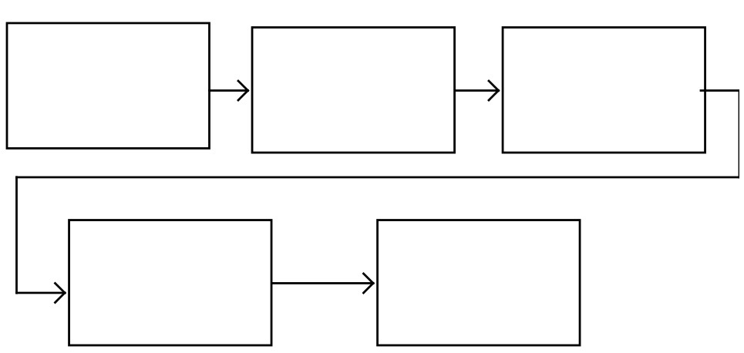
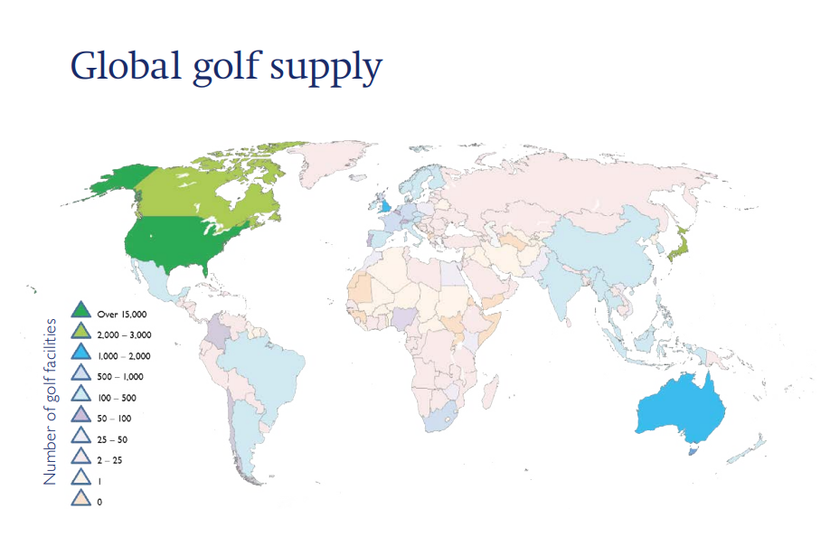
As shown above, the countries are colour coded for amount of golfing facilities. file://e4039s01sv001.indigo.schools.internal/fsE4039S01-StudentFolders$/cohen.sheridan/Downloads/Golf%20around%20the%20world%202017%20(1).pdf

Golf is played all around the world. There were 33,161 golf courses in 208 of the world's 245 countries as of the end of 2016. That equates to an 85 percent global diffusion rate for the sport. The top ten golfing countries have 74 percent of the world's supply of courses: the United States, Canada, Japan, England, Australia, Germany, France, Scotland, Sweden, and South Africa.

The western hemisphere accounts for the majority of global supply. North and South America account for 55 percent of global supply, with the United States alone accounting for 45 percent. Europe has the second greatest regional share, accounting for 22% of the global total, followed by Asia (14%), and Oceania (6%).
By the 1920s, tournament golf had established itself as a popular spectator sport in the United States, and it has only grown in popularity since then. Golf has become more popular as it has become increasingly televised and marketed around the world.
Though golf has long been associated with private clubs where play is largely restricted to members, 75 percent of courses are open to the general public on a “pay per play” basis.
What is the spatial distribution of golf?

The length of the course changes
Difficulty isn’t the only reason courses have been lengthened by golf clubs. The new technology that has gone into golf clubs has made hitting a long drive easier. It is also making it difficult for courses to keep players from reaching the green too quickly.
By increasing the length of a golf course, the slope and rating of a course will change, too. However, in most cases, it will stay the same. The reason it will stay the same is due to the course being able to keep its difficulty now that players are able to drive the ball much farther than they previously could.
Today, most professionals are able to drive a tee shot 290 yards. In 2000, Augusta National, the home of the legendary Masters tournament, was measured at 6,985 yards. However, 10 years later, Augusta had increased in length to 7,435 yards.
The reason for the increase in length is due to golfers being able to drive a ball much farther than they did in years past. In 1980, only six PGA golfers could hit the ball 270 yards from a tee shot.


-High-tech science and technology has led to the high performance golf ball and the game of golf we play today.
-Rubber-core golf balls, 1899. Longer off the tee, but lively around the green.

-Gutty golf balls, 1848 (Rev. Dr. Robert Adams). Made out of Gutta Percha. The Gutty golf ball was created from the dried sap of the Sapodilla tree. Rubbery feel and was heated up and shaped while hot. Lasted from 1848-1890’s. Affordable, playable and durable, it had a big impact on the game of golf.

-A bucket of boiled goose feathers to make a single feathery ball. A feathery maker could only make about 4 of them in a day. A feathery could only last 2 rounds.
-Feathery golf balls, 1618. The leather sac is filled with boiled goose feathers then stitched and painted. These were expensive and easily damaged. Feathery golf balls were often sold for more than a golf club.

-Wooden golf balls were made in the 1400’s out of beech or boxroot and were used up until the 17th century when the feathery ball was invented.

Changes to the golf ball

-1826, hickory for club shafts (Robert Forgan). Hickory became wood of choice for club makers.
-1925, steel shaft introduced in the US. Steel shafts provide greater accuracy and durability.
-1900, persimmon became the material of choice for wooden club heads.
-1750, the first club heads made of iron began to emerge for wedges.

-1908, grooves on club face made the ball go further and increase back spin.
-In the 1500’s there were longnoses, grassed drivers, spoons, niblicks and cleets (Drivers, fairway clubs, short shot clubs, wedges and putters. The shafts were made from ash or hazel and the club heads were made from apple, holly, beech or pear.

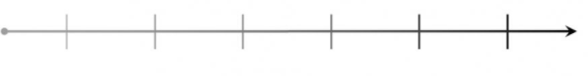
The golfer has evolved from making their own clubs from wood to now having them manufactured with advanced technology. This gives golfers the ability to personalise their clubs to their needs.
The golf club changes
The first golf clubs were usually carved by the golfer themselves and out of wood. Golfers then went to craftsmen to produce higher quality equipment.

-1970’s, Karsten Solheim invented the ping putter, which had more weight at the heel and toe which enabled golfers to put straighter.

-Up until 1939 it was common to carry 20-30 clubs until the R&A introduced the 14-club rule.

